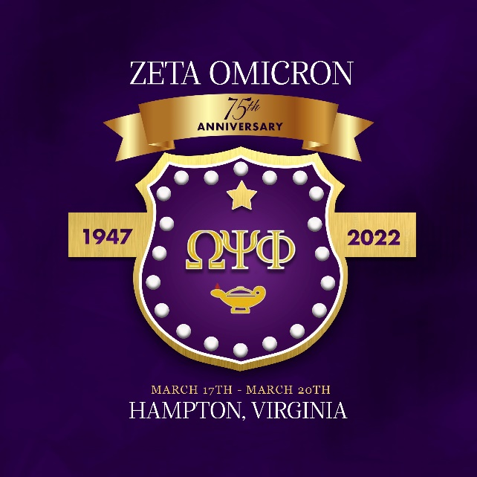
On behalf of the members of Zeta Omicron Chapter of the Omega Psi Phi Fraternity, Inc., we invite you to become an advertisement sponsor for our 75th Anniversary commemorative souvenir booklet. Zeta Omicron provides academic scholarships to high school seniors and participates in numerous community service projects while providing countless man hours to benefit mankind.

Name

Address

City, State, Zip

Phone

Email

DEADLINE: MARCH 3, 2022
Please send your ad information as soon as possible

Place an ‘X’ beside your  desired page size | Page Size | Donation
 | Full Page | $150
 | Half Page | $100
 | Quarter Page | $75
 | Inside Front Cover | $250
 | Inside Rear Cover | $250
 | Outside Rear Cover | $300

Payment & Ad Submission Options
Option 1
Email this completed form and artwork to: ads@omegapsiphi.org
Cash App payment to: $zo75th
(Use “Ad Payment” payment in the FOR field)

--- OR ---

Mail payment to:

Zeta Omicron Chapter
PO BOX 99
Hampton, VA 23669-0099

Make checks payable to Zeta Omicron Chapter

Option 2

Email artwork to: ads@omegapsiphi.org

Mail this completed form and payment to:

Zeta Omicron Chapter
PO BOX 99
Hampton, VA 23669-0099

Make checks payable to Zeta Omicron Chapter

